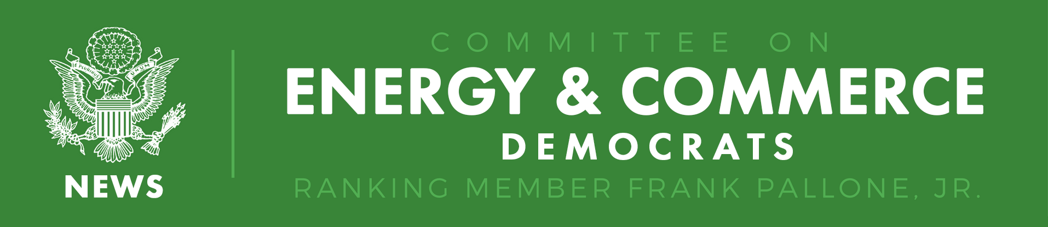

FOR IMMEDIATE RELEASE  May 16, 2018 | CONTACT  CJ Young – (202) 225-5735

Pallone Remarks at Telecommunications National Security Hearing

Washington, D.C. – Energy and Commerce Ranking Member Frank Pallone, Jr. (D-NJ) delivered the following opening remarks today at a Subcommittee on Communications and Technology hearing on “Telecommunications, Global Competitiveness, and National Security:”

American broadband providers spend tens of billions of dollars every year to improve and extend our communications networks. The return on this investment is that our networks are fast, powerful, and global. But these benefits can be turned against us in an instant if the networks are not also secure.

Every day we hear about hackers cracking our systems and stealing our data. But another risk lurking in our networks may be even more dangerous—other nations quietly watching everything we do online.

Unfortunately, a vast majority of our network equipment is now manufactured overseas by foreign companies. Most of this equipment works well and causes no problems. But our intelligence agencies have identified certain companies like Huawei and ZTE from China as posing specific threats to our national security.

This equipment may have built-in backdoors that allow other countries to vacuum up all of our data. Once installed, these backdoors can be nearly impossible to detect.

These risks are so serious that it led the Trump Administration to float the idea of just building a federalized wireless network. While this solution was widely panned, the underlying threat that led to this proposal is real.

On the other hand, U.S. networks depend on equipment from foreign companies as they race to build next-generation networks, like 5G wireless technology. For many broadband providers, less expensive Chinese equipment may be the only option.

These issues are complex. But rather than crafting a coherent plan forward, the Trump administration has made this problem significantly more difficult. With a tweet, the President muddled his own foreign policy—if he had one. After the Commerce Department announced strong sanctions against ZTE for risking our national security, this weekend the President tweeted that he is now worried these sanctions will cost jobs in China. This makes absolutely no sense.

That’s why we need to hold more hearings like this one. The public needs to hear more about the national security risks at play. And Congress needs to spend more time understanding potential options. The worst thing we can do is to rush to act without evaluating unintended consequences and whether certain proposals can even solve the problem.

Unfortunately, some of our colleagues on the Armed Services Committee are suggesting we do just that. A proposal has been put forward as part of the National Defense Authorization Act that would cut-off access to a wide array of network equipment without considering how to manage the risks to Americans. Worse, these provisions in the bill have been specifically crafted to circumvent our jurisdiction. Maneuvers like this rarely result in good policy.

Rather than take rash action, Congress must carefully craft a coherent plan subject to the rigors of regular order in the Committees of expertise like ours. Our plan should make our networks both more robust and more secure. We are dealing with a complicated relationship between the future of our communications networks and national security. These issues should not be taken lightly.

I urge my colleagues to oppose these efforts. We must find a proper balance that keeps our country safe while still ensuring that every American has access to powerful next-generation broadband networks.

Finally today, a bittersweet announcement, David Goldman, our Chief Counsel on this subcommittee, will be leaving at the end of this month to pursue an opportunity in the private sector. This is his last hearing. I say this is bittersweet because over the last three years he’s been an invaluable part of the Committee team. David has provided us not only critical policy expertise but also strong strategic guidance that helped lead to the passage of the bipartisan Ray Baum Act, which included a lot of important Democratic priorities, including the SANDy Act. David has a long career of public service – including time at the FCC and in the Senate.

David --- you’ll be missed and we wish you nothing but the best in your future endeavors.

Thank you, I yield back.

###

democrats-energycommerce.house.gov | Twitter | Facebook | Instagram | YouTube | Flickr

